If you just got a Vault Collaboration tattoo, I’ve got bad news for you. The product is no longer there in the 2014 release. The 2014 product line consists of Vault Basic, Workgroup and Professional.
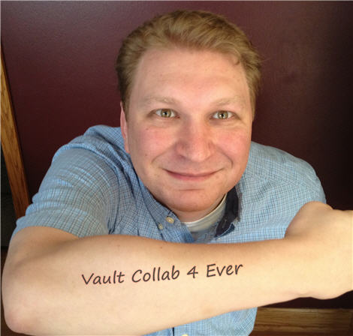
Oh well. At least I still have my Google Reader tattoo.
I will be focusing on the technical content, like I always do. If you have questions about pricing, support and migration, see your reseller. My understanding is that things have been adjusted to make the Collab->Pro transition as smooth as possible for existing customers.
Feature set
There has been no impact on the product feature sets. Vault Basic, Workgroup and Professional still have all the features they did from before. Items and Change Orders can be hidden in Vault Pro if you are not interested in those features.
Impact on the API
There are some spots in the API that still reference Vault Collaboration. The decision to remove the product was made after the API was locked down. The Vault Collab stuff should affect the API; it should just be dormant code. If you experience any issues, let us know.
Custom Objects all around
My biggest problem with Vault Collaboration was that A) it didn’t have custom objects, and B) the AEC community was encouraged to use that product. As a result, the AEC customers did not have custom objects, which is one of the most powerful tools for Vault customization.
With Vault Collab gone, AEC customers are being moved to Vault Professional. That means your apps can use custom objects all you want without alienating any industry group.

That’s all I have on this topic. It’s pretty straightforward. Now if you’ll excuse me, I have an appointment at the laser center.

